Notable Achievements
- We had a 32% increase in membership this year.
- 177,220 books, eBooks and eAudiobooks were borrowed throughout the year.
- As part of our Door to Door delivery service, 6,968 books were delivered to 1,377 readers across the county.
- 13,000 Bookville Activity Books distributed to all 88 primary schools across Kilkenny as part of our annual Bookville Kilkenny Festival.
- We had 85,847 video views across our social media and YouTube platforms.
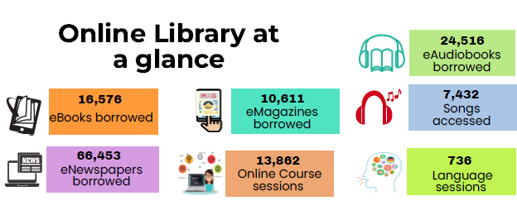
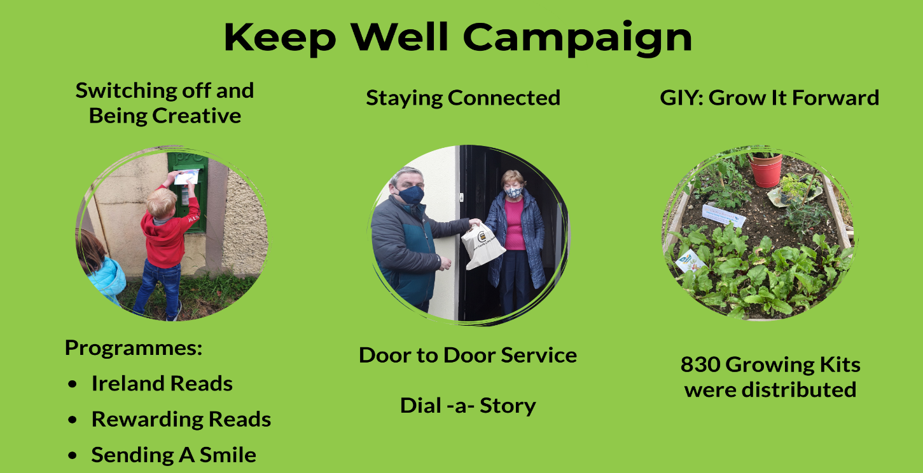
National Initiatives
- Right to Read: All strands of Right to Read proved extremely popular this year – we ran a host of storytimes, online workshops and events for Spring into Storytime, Summer Stars, Children’s Book Festival and Family Time at Your Library.
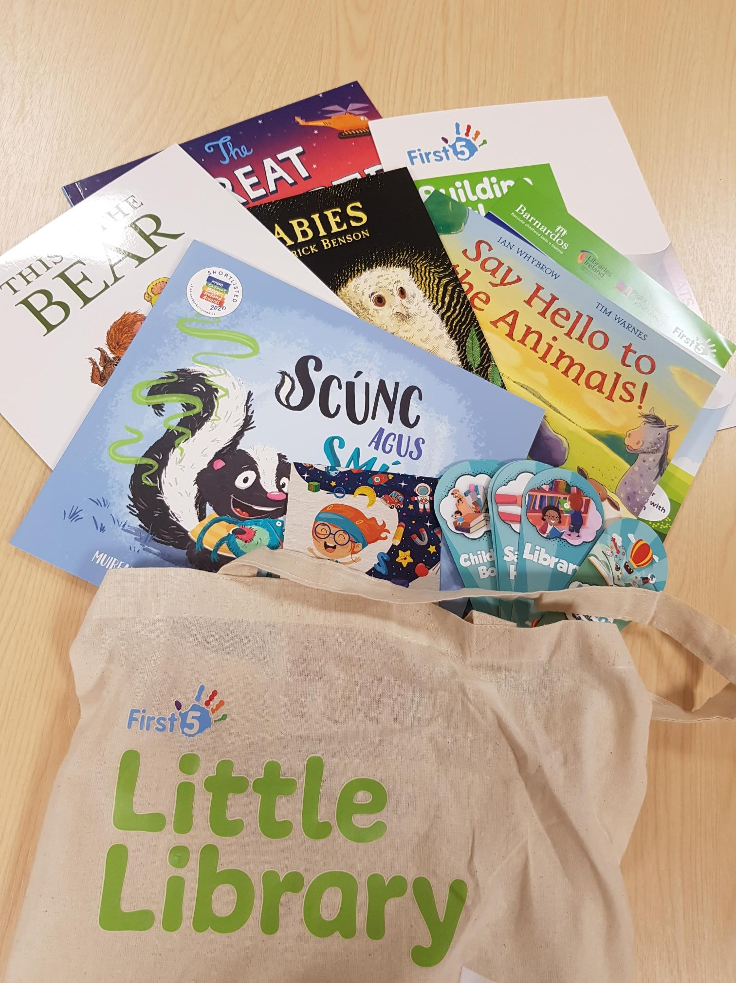
Ireland Reads: Our new national day of reading was held on 25th February, and we ran a series of talks and workshops for all ages, with over 3,000 views of our online events.
Little Library Bag: We engaged with 90 Early Learning Centres and childminders as part of this project, giving out 1,380 books to encourage a love of reading and books from an early age.
- Work Matters: We collaborated with Kilkenny Carlow ETB to run a series of online webinars for jobseekers and businesses on interview skills and using social media and other platforms to promote business, whilst profiling a new local business to share the challenges and avenues they found helpful.

- Healthy Ireland At Your Library: We ran a series of online talks throughout the year on a range of topics such as: Raising Resilient Children with Dr. Mary O'Kane, Coping with Neuro-diverse diagnosis with Fiona Hall, and partnered with Health Kilkenny coordinator on a Healthy Food Made Easy cookery course. We also developed a musical recording entitled “Those were the days’, celebrating classic sing-along- songs with a bit of fun and comedy thrown in! This was run online and also sent to each nursing home in Kilkenny in December.
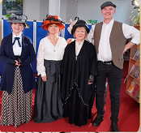
- Age Friendly Programme: Age Friendly Digital Ambassadors Programme offered one-to-one remote training in use of our online library platforms. We celebrated Bealtaine with an online series of flower arranging, planting, decluttering your home workshops, and a webinar on coping with grief. Our mobile magic tables are being loaned to nursing homes in Kilkenny for use and are proving very popular.
- Decade of Centenaries: We engaged a local historian and a local author to develop a series of 13 podcasts on 1921 themes, and commissioned two publications covering significant local events on The Kilkenny Jail Break and Ballykinlar Internments.
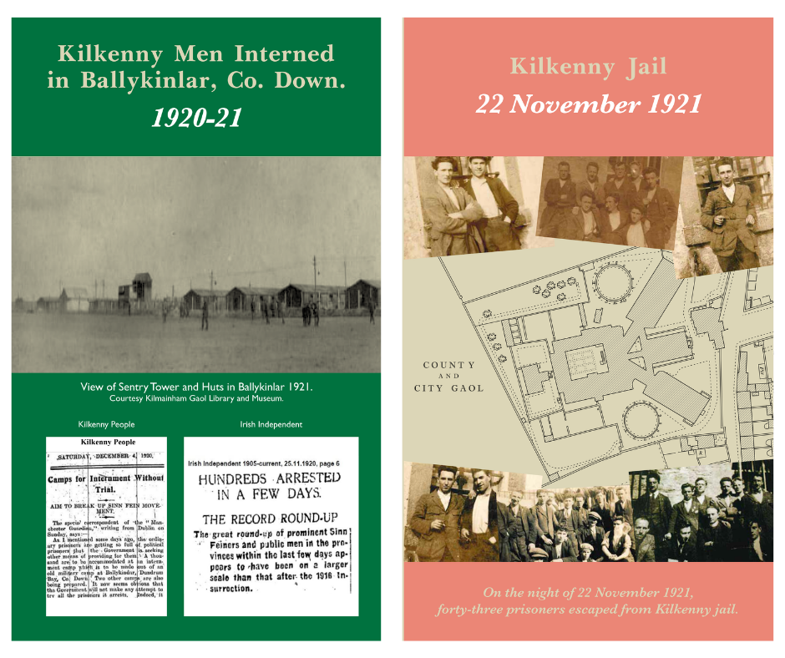
- Creative Ireland:
Bookville Kilkenny: We developed and delivered 13,000 activity books to primary schools in Kilkenny and ran 15 online workshops for families and children. Every child in primary schools in Kilkenny received a book, making the festival fully accessible.
Slí na Scéalta: We received funding to develop an outdoor Story trail which will be launched in early 2022 in Woodstock, Inistioge.

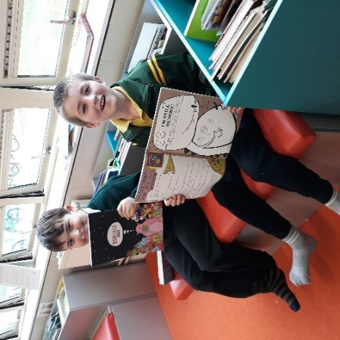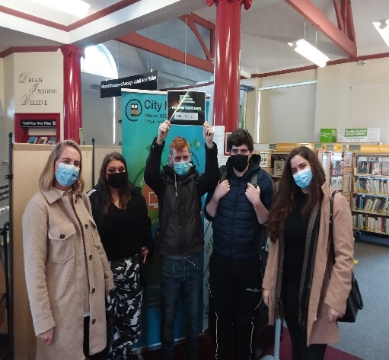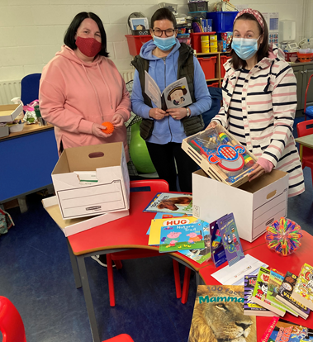
Gaelscoil Osraí students enjoying Bookville Students enjoying Science Week Escape Room ASD packs delivered to units across Kilkenny

Programming and Events

- Sensory Resources: Our sensory collection was expanded to include 150 toys and 300 books, social stories for each library and sensory boxes for use in the branches. The new collection is based centrally allowing easier access for all. As part of our Encouraging Minds Literacy Project, Staff and students at 18 ASD and language units all over Kilkenny received specialist motor skills resources and sensory books in March.
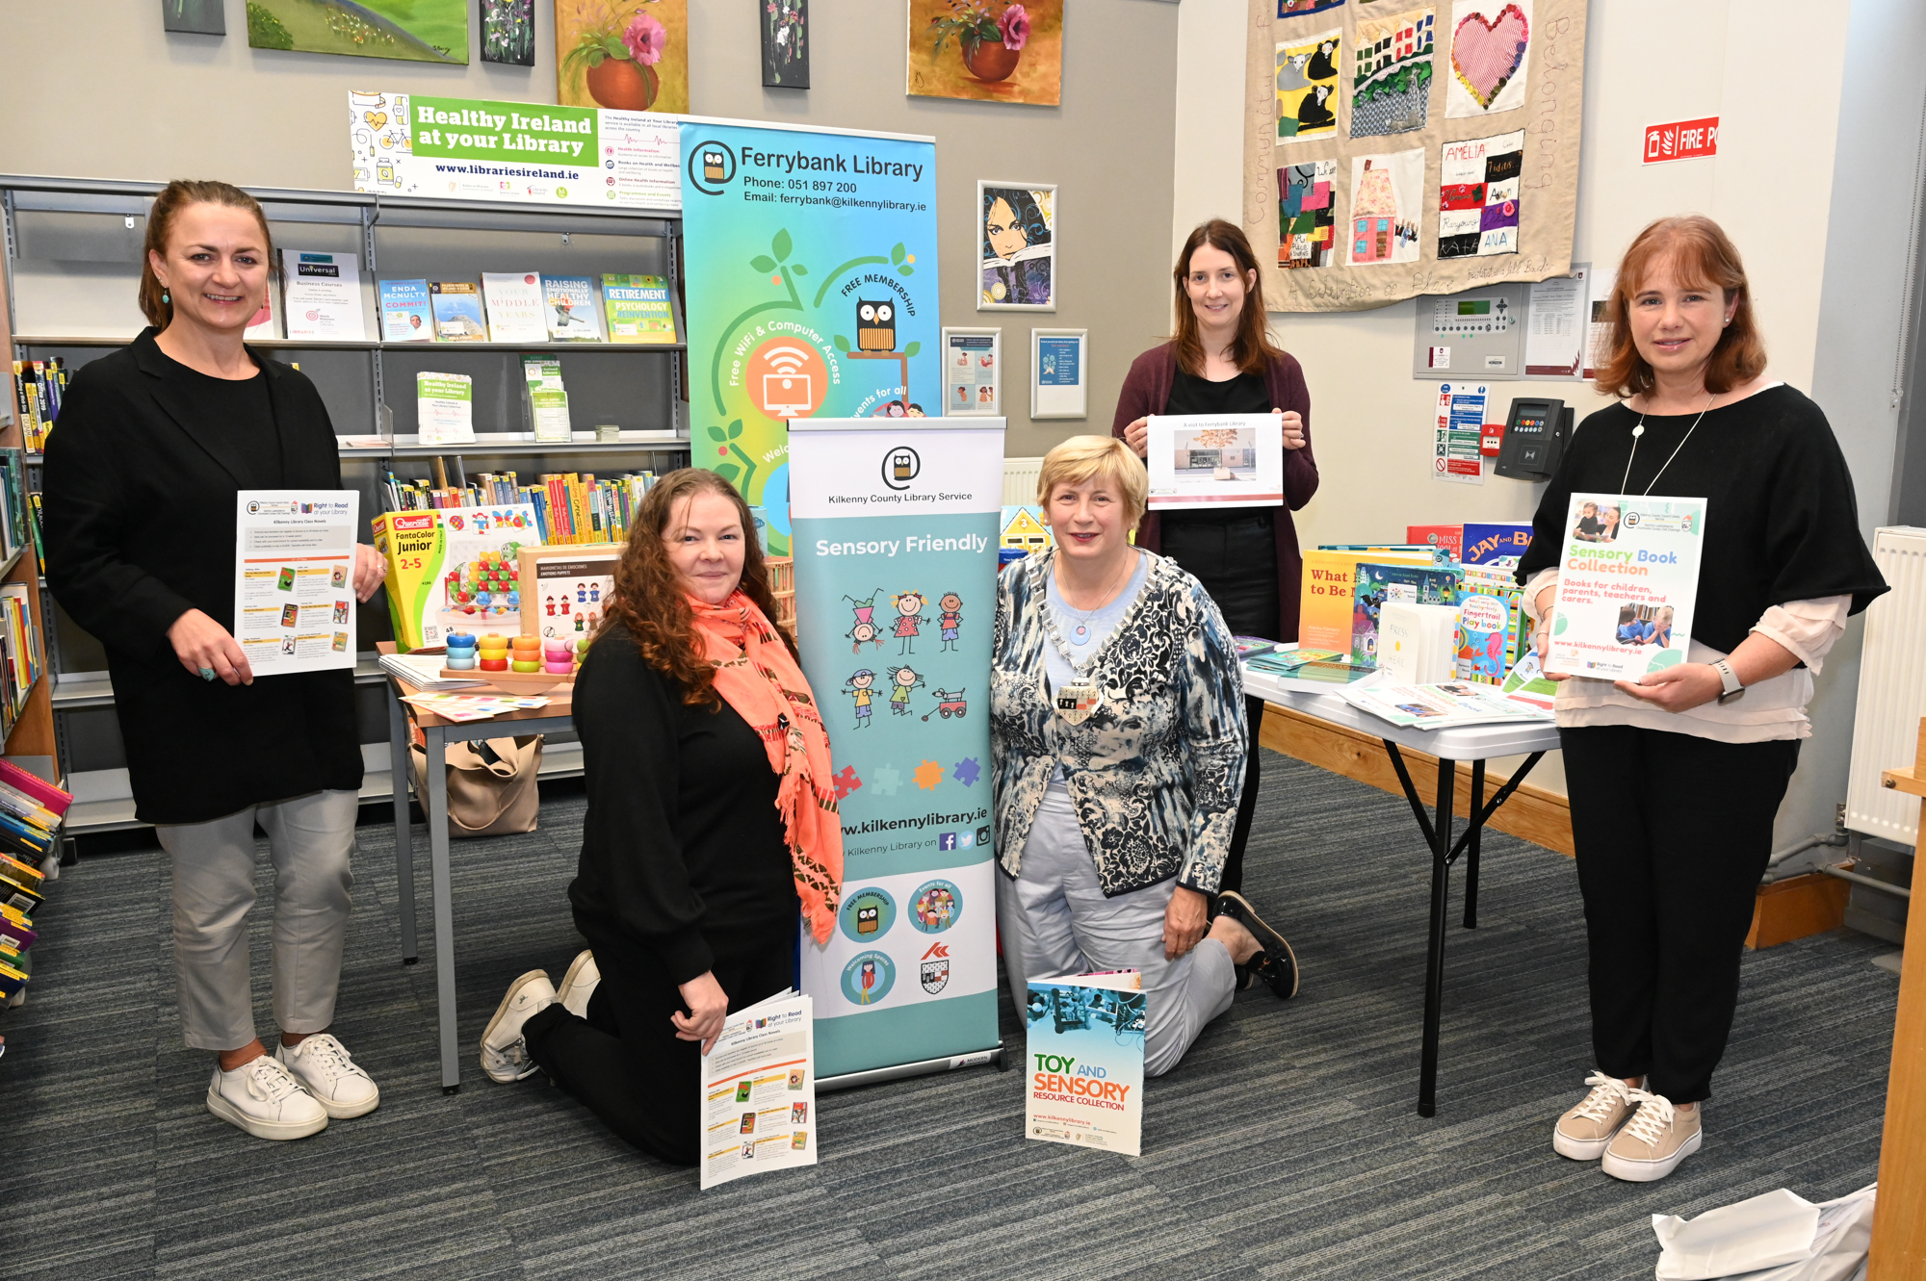
- Virtual Book club: Our Virtual Book continued to thrive this year, offering a 24/7 space to discuss and recommend books with over 100 other members.
Sensory Toy and Book Launch in Ferrybank Library

- OWL: Our Oral Language literacy programme focused on developing the oral language skills of 0-3 year olds, by helping support parents, childcare practitioners and teachers to ensure a good oral language base from an early age. These short online workshops were developed by a Speech and Language Therapist, Behavioural Specialist and Storyteller Neil Griffiths. These proved extremely popular amongst parents and childcare workers.
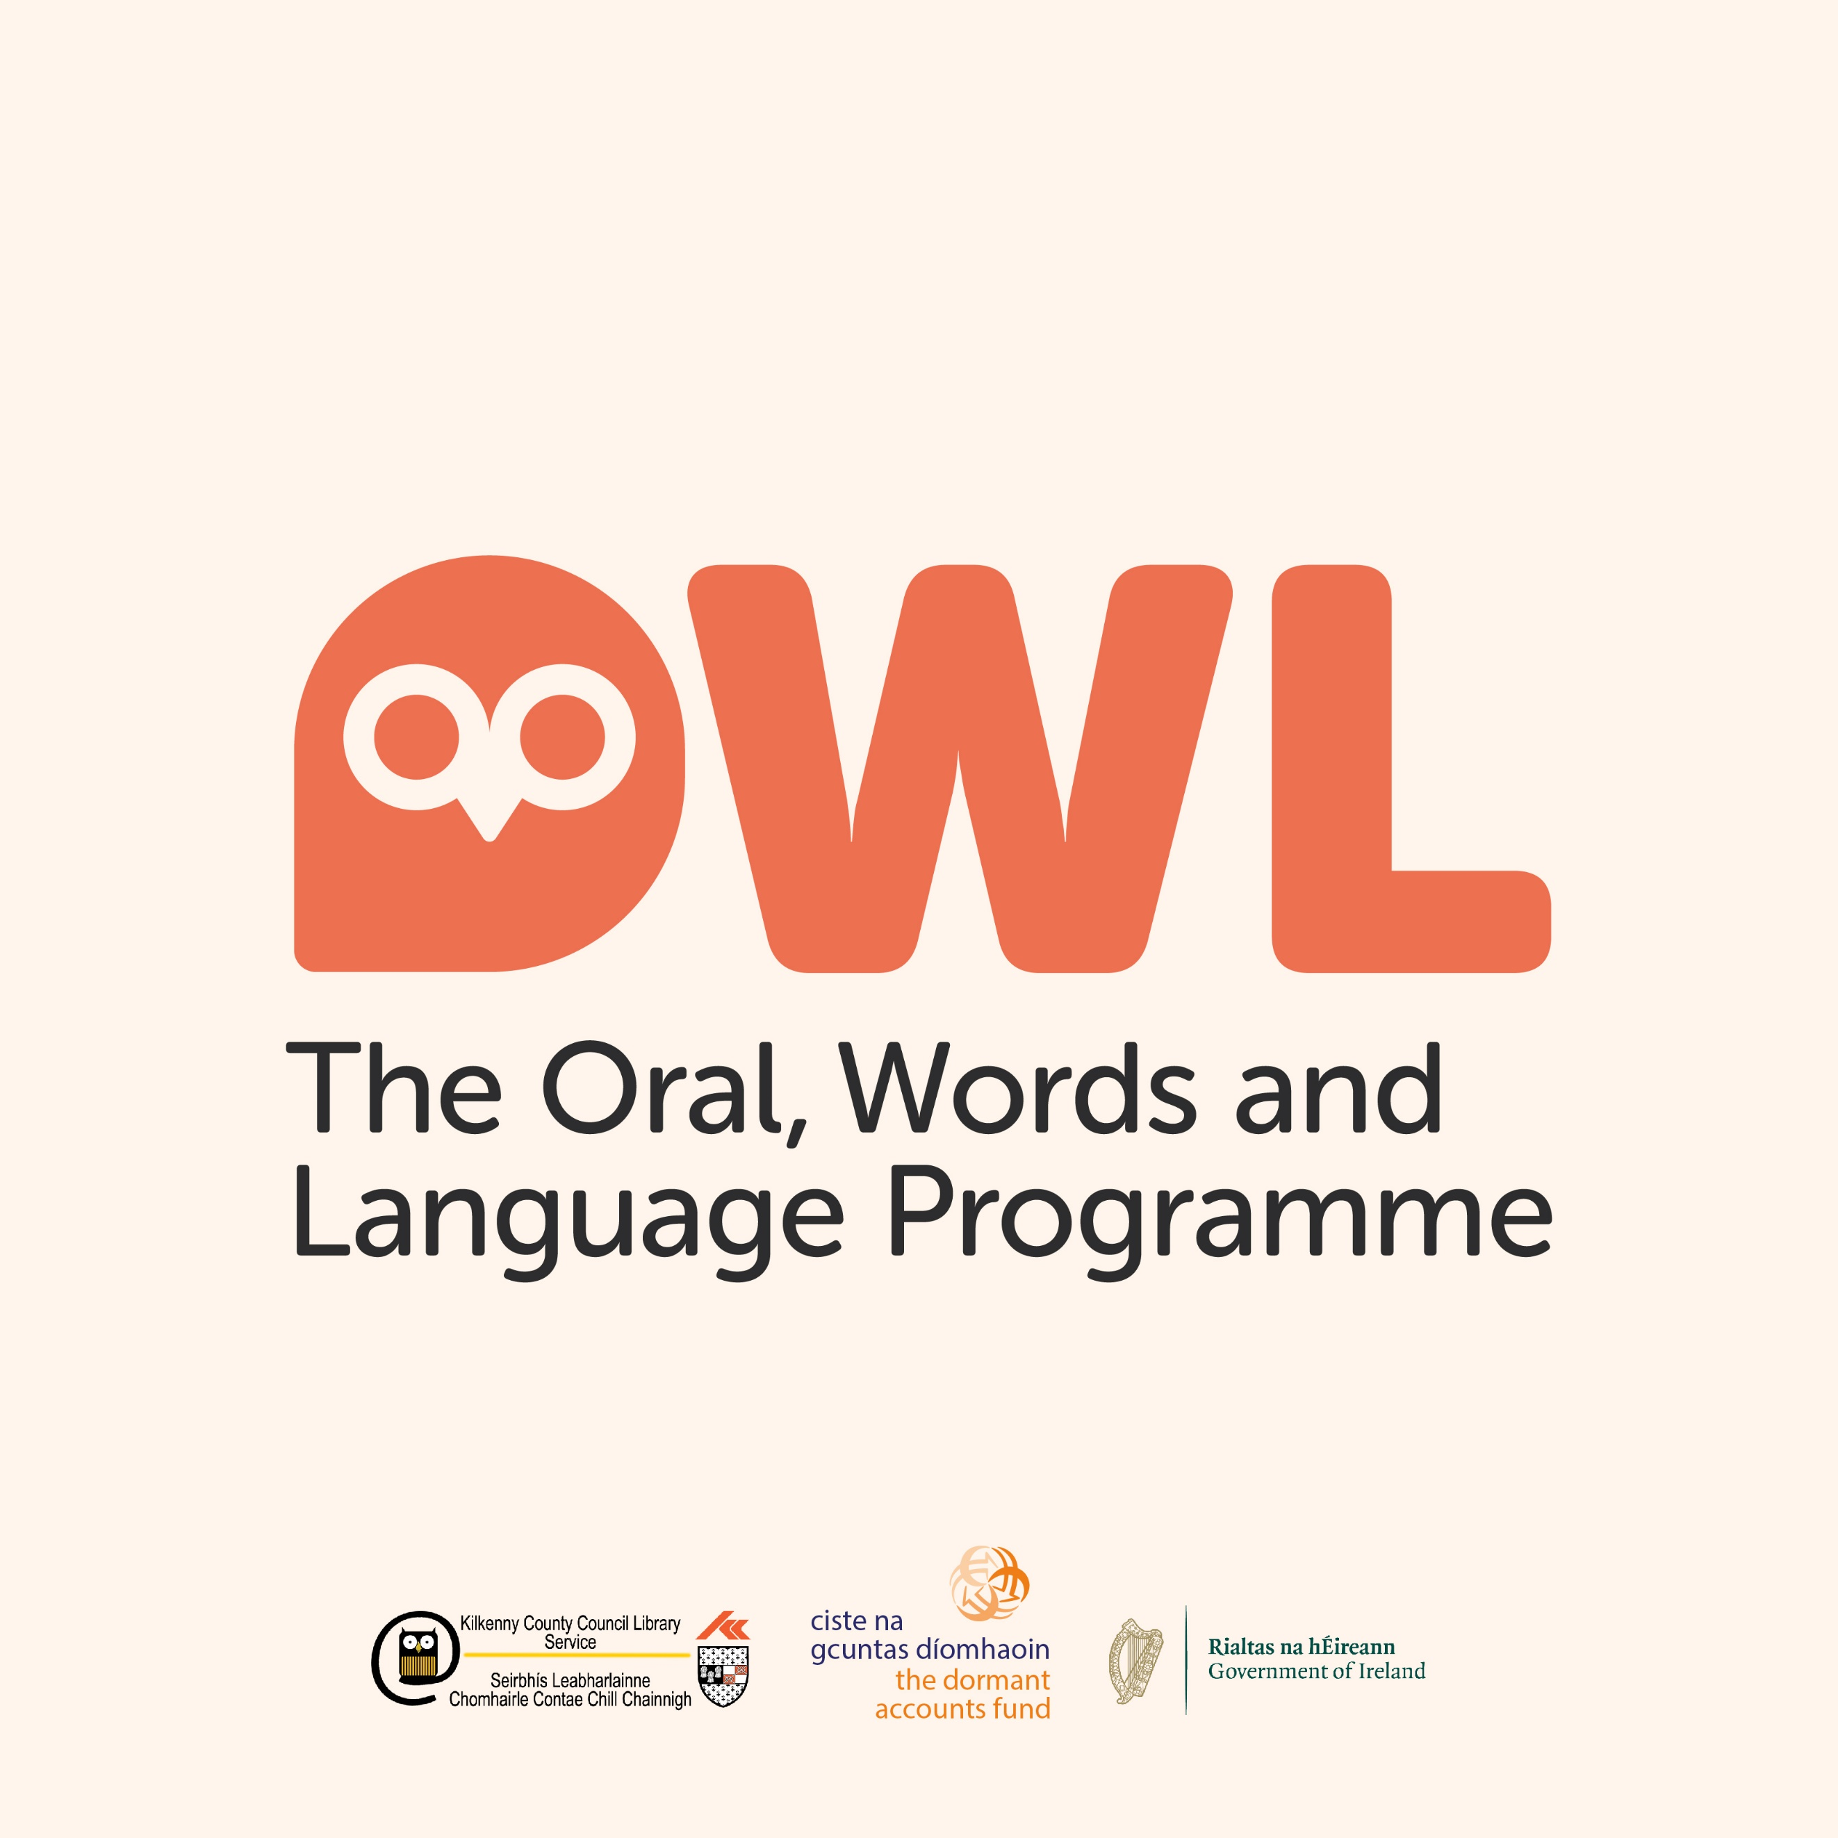
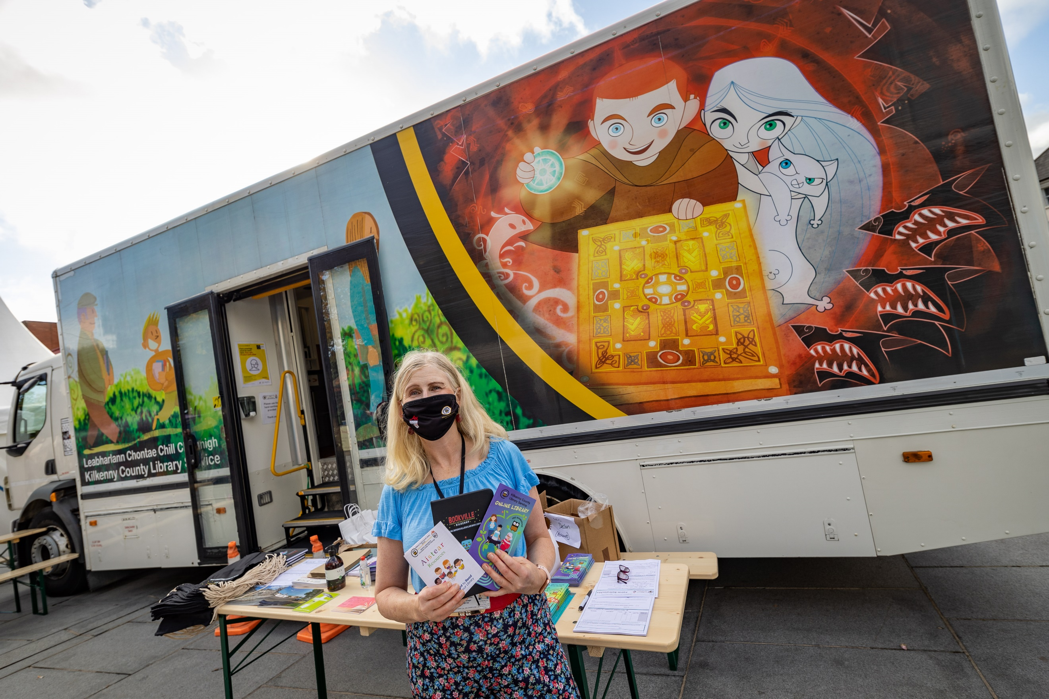
- We actively collaborated and partnered with a range of organisations, agencies and community groups such as Kilkenny Carlow ETB. Kilkenny Education Centre, Kilkenny Childcare Committee, Healthy Kilkenny, Music Generation, HSE, and Calmast. We participated in national and local festivals such as Kilkenny Day, Seachtain Na Gaeilge, National Poetry Day, Decade of Centenaries, Bealtaine, Heritage week and Science week.
Mobile Library at Kilkenny Day

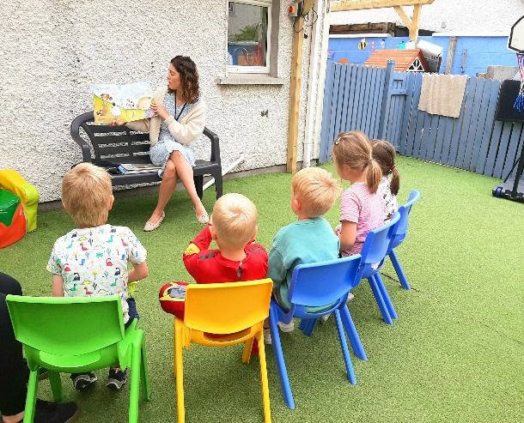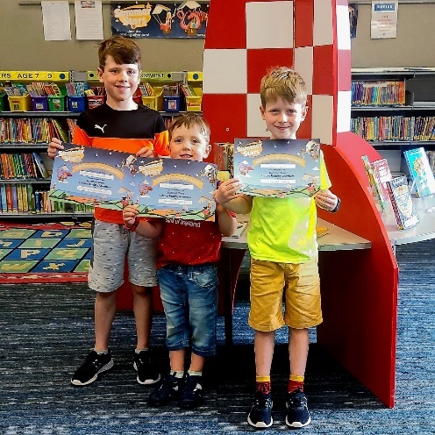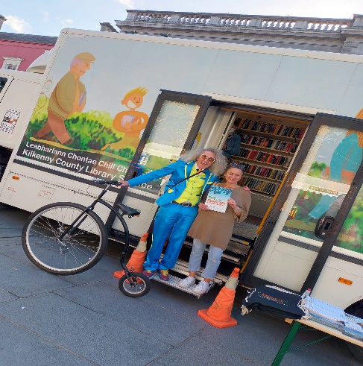
Staff Storytime at Thomastown Creche and Montessori Ferrybank Readers completed Summer Stars Mobile Library on Kilkenny Day
Information and Communication
- We engaged in various platforms and media to engage people with our services, facilities and events. We had 85,847 video views across our social media and YouTube platforms.
- Eduroam (education roaming) is a wifi service which enables 3rd level students, researchers and staff from participating institutions to securely access the internet at their college/university remotely. This has been installed in Callan, Thomastown and Ferrybank Libraries.
- Capacity Management Systems were installed to ensure safe management of numbers visiting our libraries.
- C-Pens were purchased for each library and 4 accessible PC monitors were purchased through grant funding.
- Coding Licences were purchased for children paged 6-14+ to improve digital literacy amongst young people in Kilkenny.
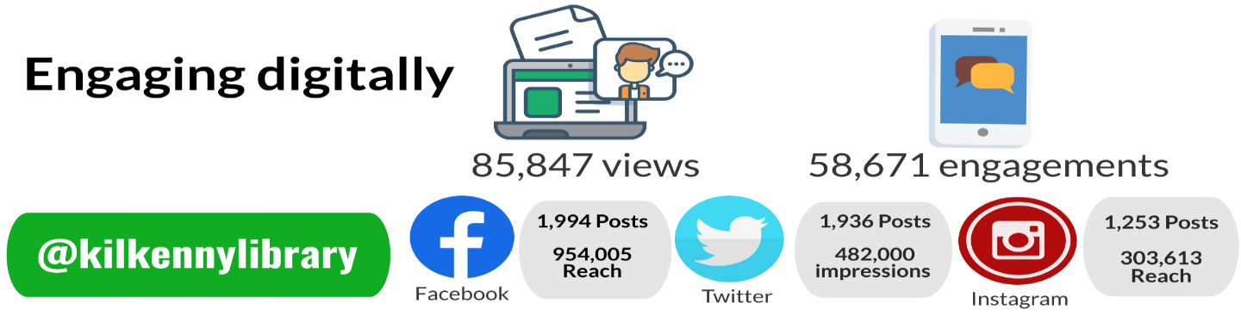
Reading Supports

- Schools Services: Our school services were further expanded this year, with a dedicated section added to our website, offering access to widely relevant resources. We invested in and developed brochures for our class novel collection, sensory book collection, sensory book and toy collections, and Aistear collection. A teacher’s resource pack was developed and will be distributed in 2022. Monthly interactive mailings were sent to schools with storytimes and crafts for children of all ages.
- Mobile Library Service: Our mobile service routes were evaluated using evidence-based methods, and changes put in place to best serve our rural communities. Additional nursing homes, schools and early learning centres were added, and a number of community stops were transferred to our Door to Door service. Our mobile van was also part of Kilkenny Day celebrations.

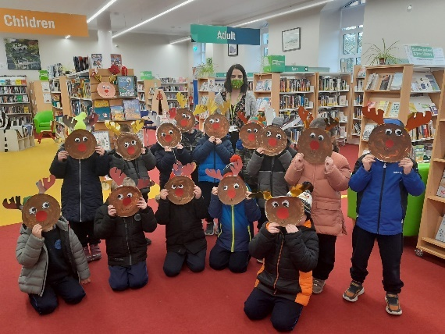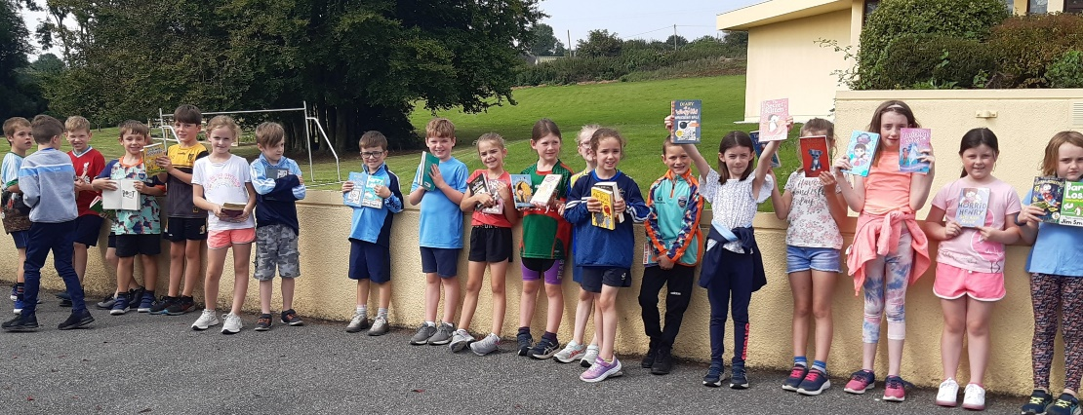
Presentation Convent Castlecomer visited to show St. Aidan’s NS Kilkmanagh were delighted to get some new books from the mobile library.
Johanna what they made from their library craft packs.
Income
We successfully applied and were awarded €91,335.49 from a range of funding sources including Dormant Accounts Fund, Decade of Centenaries, ETB, Small Scale Capital Fund, Creative Ireland and Healthy Ireland.

Service Development and Infrastructure
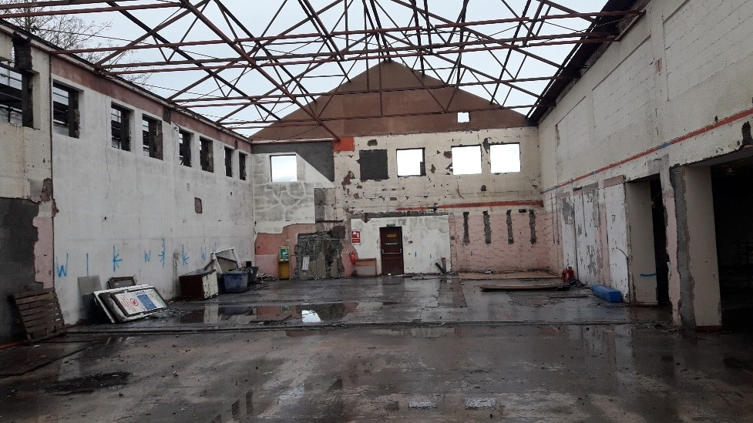
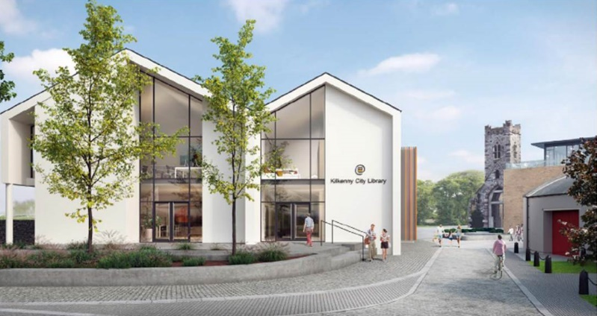
- Commencement of capital project in Mayfair Library in November 2021
- Progressed capital project in Thomastown to design stage
- Replacement of roof in Graiguenamanagh Library
- Revamp of internal space in Castlecomer to ensure accessibility

Workforce
Kilkenny Library Service continues to proactively upskill and train staff in relevant areas to enhance the service we provide to our diverse community. Specialised Library training courses were completed by a large number of staff, with 2 staff currently training for a professional qualification in Librarianship. Progress also continued on our workforce plan.

